ITEM DETAILS
Name of Item | Victorian Terrace
Other Name/s  Former Name/s | 27 Bennett Street, Bondi
Item type | Built
Item group | Residential Buildings (private)
Item category | House
Area, Group, or Collection Name | Unknown
Street number | 27
Street name | Bennett Street
Suburb/town | Bondi |  |  |  |  | Postcode |  |  | 2026
Local Government Area/s | Waverley
Property description | Lot 54 DP 561
Location - Lat/long | Latitude | -33.895364 |  | Longitude | 151.260054
Location - AMG (if no street address) | Zone |  |  | Easting |  |  |  | Northing
Owner | Private
Current use | Residential
Former Use | Residential
Statement of significance | 27 Bennett Street, Bondi (c1894) is a notable example of a two-storey freestanding Victorian Italianate residence which represents the first phase of development of the 1882 Bennett’s Estate subdivision. It demonstrates the optimism following the 1890 depression in the lead up to Federation.  It is a rare example of a two-storey freestanding Victorian Italianate residence in Waverley.
Level of Significance | National |  | State |  |  |  | Local

DESCRIPTION
Designer

Builder/ maker

Physical Description | 27 Bennett Street, Bondi, is a two-storey freestanding villa that dates from the Victorian period, a key period of significance, and reflects the subdivision of the Bennett’s Estate, 1853. The building displays features of the Victorian Italianate style including asymmetrical massing, prominent tower element with pyramidal roof, Free Classical detailing, stucco wall finish, and medium-pitch roof. While the building is altered, the alterations are easily recovered. The building is setback 8 metres from the street on a site approximately 12 metres wide, that reflects the original subdivision pattern in a suburban setting that has lost its historic context. The site has a fence of iron palisade rendered masonry approximately 2 metres high, which detracts from the setting of the place. The site is informally landscaped and features steps, elevated terrace paving, hedging, exotic vegetation and provides an appropriate setting for the structure. The building has been altered but is in fair condition.  Elements impacting upon the integrity of the site include verandah infill to either side of tower element, gable end facing sheet, retaining wall steps and elevated terrace.
Physical condition  and  Archaeological potential | The building appears to be in fair condition
Construction years | Start year |  | Finish year |  | Circa | c1894
Modifications and dates | Addition of a tower and verandah to the north sometime between 1894-1943. 1976 alterations designed by Cyril Smith; timber gable infill, timber verandah spandrel, render, rear stair, and new windows (BR 76/408).

HISTORY
Historical notes | 27 Bennett Street, Bondi was part of Edward Bennett’s 10-acre grant of 1853 which was subdivided by Frederick Burt and Edward Bennett under DP 561. The Bennett’s Estate Waverley was offered for auction sale on 16 September 1882. The estate offered 66 residential building sites fronting Bennett, Birrell, Park and Bondi Road (then Waverley Street).  The subject site is Lot 54 in DP 561. Lot 54 and the adjoining Lot 20 fronting Park Parade were purchased by John Tanner, a boot manufacturer, in December 1881. In 1888, Tanner sold to Isabel King, wife of Hardinge King, a conveyancer. King sold to Thomas Haggett, a postman of Guildford. Haggett sold to solicitor Richard Meagher two months later.  The structure is evident in the 1894 survey. In 1912, Lot 20 was sold off to George and Allan Penson, builders of Paddington. The 1943 aerial indicates the addition of a tower and verandah to the north since 1894. In 1976, architect Cyril Smith proposed alterations including timber gable infill and timber verandah spandrel, render, rear stair, and new windows (BR 76/408).

THEMES
 | National historical theme | 3 Developing local, regional and national economies  4 Building settlements, towns and cities  8 Developing Australia’s Cultural Life
 | State  historical theme | Transport  Towns, suburbs and villages  Land tenure  Accommodation  Domestic life  Persons
 | Local  historical theme | Villas and Mansions  Traffic and Transport  Speculation and Subdivision

Assessment
A: Historical Significance | The site and building at 27 Bennett Street, Bondi, has historic significance at a local level as it represents the 1882 subdivision and the early development of Bennett’s Estate. The subdivision of early villa estates was an important phase in the history of Waverley.  27 Bennett Street, Bondi, has historical significance at a local level as it demonstrates the optimism following the 1890 depression in the lead up to Federation.  27 Bennett Street, Bondi, has historical significance at a local level as it demonstrates a freestanding Victorian villa which is a notable example of domestic life in the Victorian period in the local area.
B: Associative | To date no historic association has been identified.
C: Aesthetic significance | 27 Bennett Street, Bondi has aesthetic significance at a local level as it is a notable example within the precinct representing the 1882 subdivision of the Bennett’s Estate.  The building displays features of the Victorian Italianate style which features asymmetrical massing, prominent tower element with pyramidal roof, bracketed eaves, Free Classical detailing, stucco wall finish, arched opening, filigree verandah, medium pitch roof with prominent chimney and palisade fencing. While the building is altered, the key aspects of its characters are easily recovered.
D: Social significance | To date no social, cultural, and spiritual significance has been identified.
e) Technical/  Research significance | To date no technical significance has been identified.
f) Rarity | 27 Bennett Street, Bondi, has rarity significance at a local level as it is a rare example of a two-storey freestanding Victorian Italianate residence in Waverley, despite being well represented in other local government areas.
g) Representative  ness | 27 Bennett Street, Bondi has representative significance at a local level as it is a notable example of a two-storey freestanding Victorian Italianate residence which represents the first phase of development of the 1882 Bennett’s Estate subdivision.
Integrity | The building has been altered.

HERITAGE LISTINGS
Heritage listing/s | Draft Waverley LEP 2012

INFORMATION SOURCES
Type | Author/Client | Title | Year | Repository
 | Waverley Council | Waverley Heritage Policy | 2007
 | Waverley Council | Waverley Heritage Study | 1993
 | Perumal Murphy Pty Ltd | Waverley Heritage Study | 1990
Building Plan |  | BR 76/408 |  | Waverley Council

RECOMMENDATIONS
Recommendations

SOURCE OF THIS INFORMATION
Name of study or report | Heritage Policy by Waverley Council reviewed by Architectural Projects 2023 |  | Year of study or report
Item number in study or report

Author of study or report
Inspected by
NSW Heritage Manual guidelines used? |  |  |  | Yes |  | No
This form completed by |  |  |  | Date

IMAGES

Image caption | 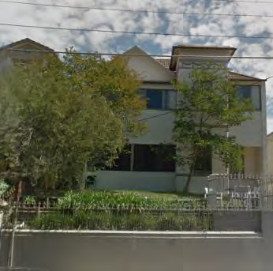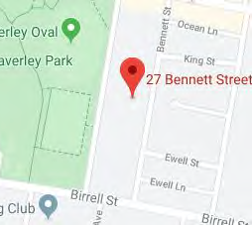
Image year |  | Image by | Google Maps | Image copyright holder

Image caption | 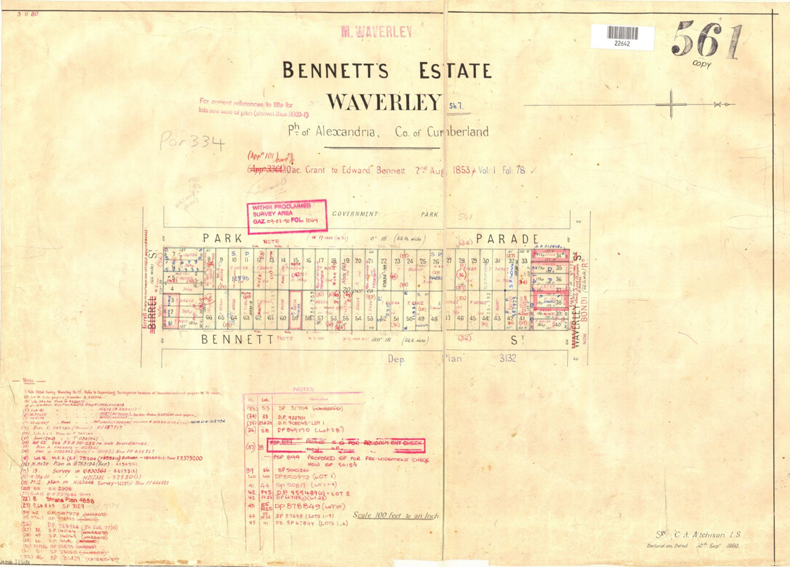
Image year | 1880 | Image by | LPI | Image copyright holder

Image caption | 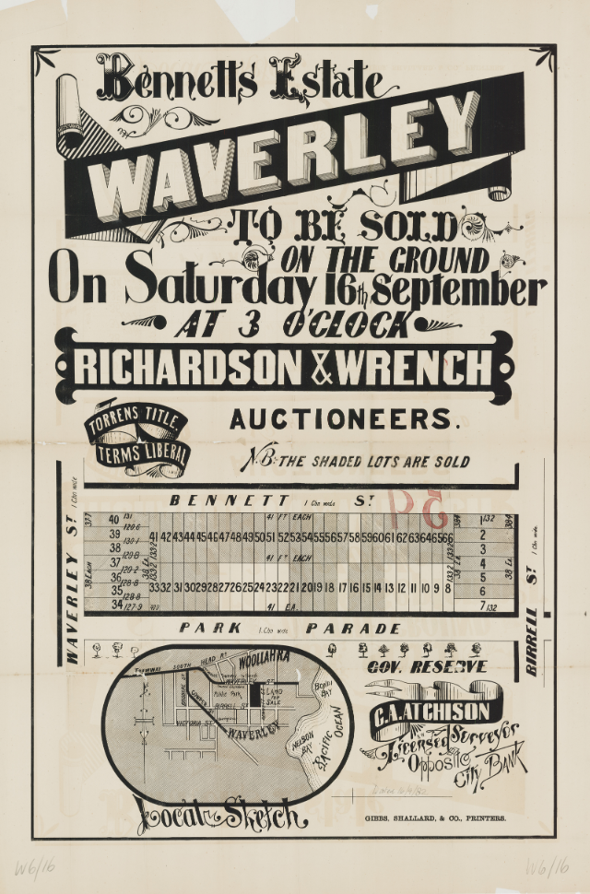
Image year | 1882 | Image by | State Library of New South Wales | Image copyright holder

Image caption | 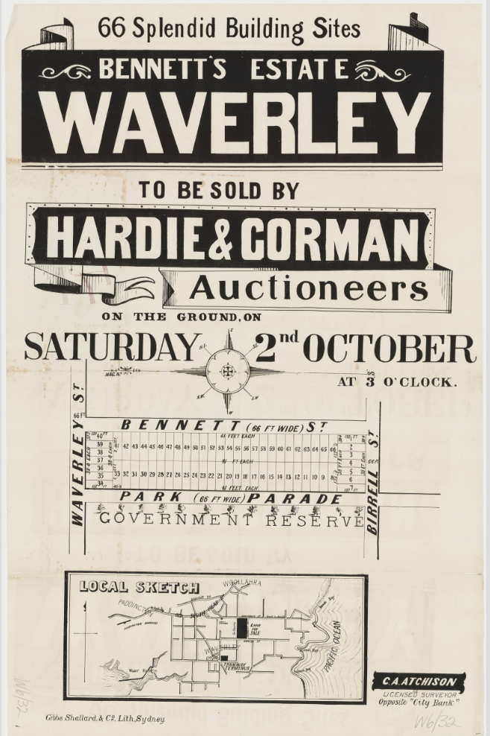
Image year | 1882 | Image by | State Library of New South Wales | Image copyright holder

Image caption | 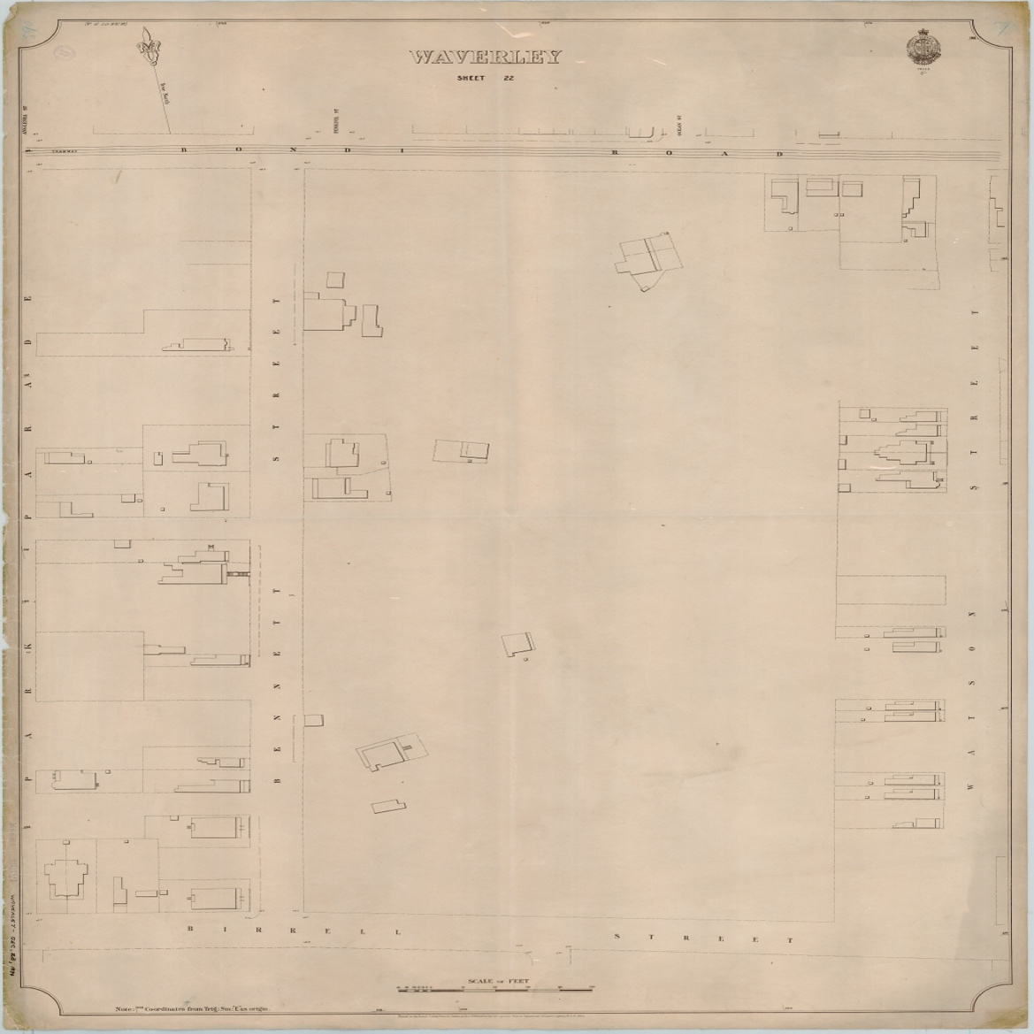
Image year | 1894 | Image by | State Library of New South Wales | Image copyright holder

Image caption | 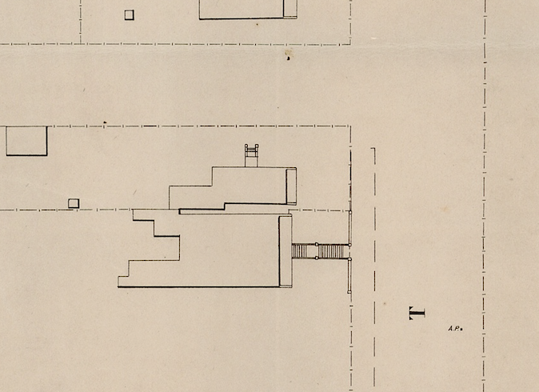
Image year | 1894 | Image by | State Library of New South Wales | Image copyright holder

Image caption | 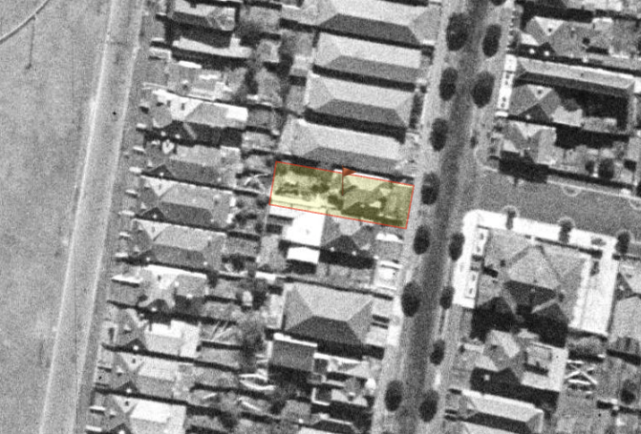
Image year | 1943 | Image by | SIX Maps | Image copyright holder

Image caption | 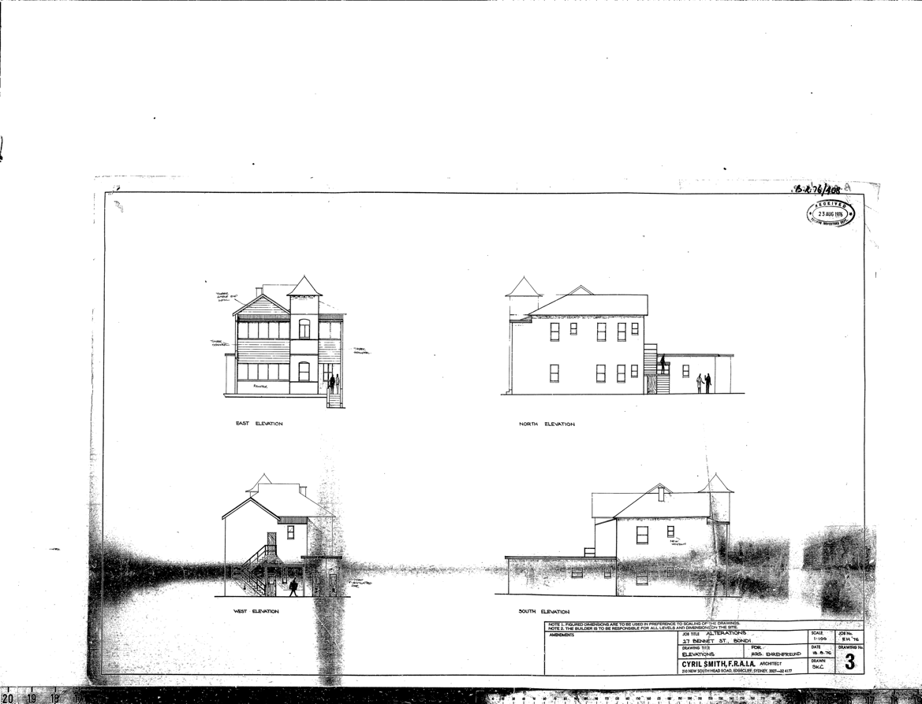
Image year | 1976 | Image by | Waverley Council | Image copyright holder

